the circle

The figure is simulated in MATLAB 2018b.

Data visualization: <https://streamable.com/dya9>r

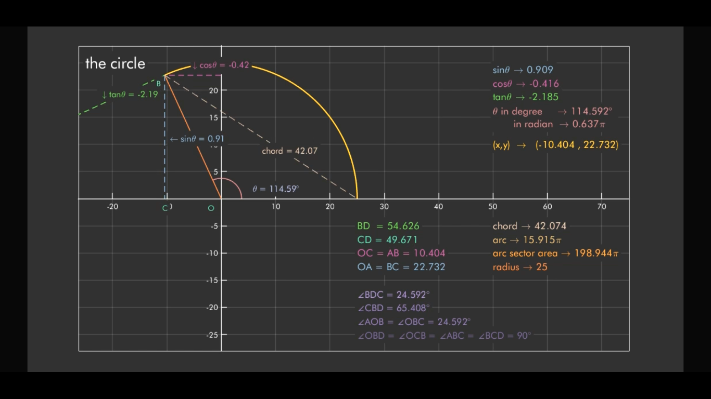

$0<θ<360$

Degree, $θ={\left(\frac{θπ}{180}\right)}^{ }radian$

Chord = $radius×\sqrt{{\left(1-\cos{θ}\right)}^{2}+\sin^{2}θ}$

Chord is the connecting line for any two points on a circle; highest at radius.

Arc = $radius×\frac{θ°π}{180}$

Arc sector area = $π×{(radius)}^{2}×\frac{θ°}{360}$

The code: (written in MATLAB)

clearvars

close(gcf)

r=input('Enter the radius of the circle: ');

increment=input('Enter the increment of the angle i.e. 0.1 or 0.01 etc: ');

ax=gca;

set(ax,'ClippingStyle','rectangle','Color',...

[0.149019607843137 0.149019607843137 0.149019607843137],'FontName',...

'Futura Bk BT','GridColor',[1 1 1],'LabelFontSizeMultiplier',2.5,...

'LineWidth',0.5,'MinorGridAlpha',0.5,'MinorGridColor',[1 1 1],...

'TitleFontSizeMultiplier',3,'XAxisLocation','origin','XColor',...

[1 1 1],'XGrid','on',...

'YAxisLocation','origin','YColor',...

[1 1 1],'YGrid','on');

box(ax,'on');

axis(ax,'square');

ax.FontSmoothing = 'on';

ax.LineWidth = 1;

ax.NextPlot = 'add';

set(gcf,'windowstate','maximized');

set(ax,'dataaspectratio',[1 1 1]);

t=0:increment:2*pi;

if r<=-1

r=-r;

end

x=r*cos(t);

y=r*sin(t);

chord=2*r*sin(t/2);

set(ax,'xlim',[-(r+r*.05) (r+2*r)],'ylim',[-(r+r*.125) (r+r*.125)])

set(gcf,'color',[0.149019607843137 0.149019607843137 0.149019607843137])

pause(3)

for k=1:length(t)

rad(k)=(t(k)*1)/pi; %radian

deg(k)=(rad(k)*pi)*(180/pi); %degree

m(k)=(y(k)/x(k)); %slope

b(k)=y(k)+(x(k)/m(k)); %the B of y=mx+b

p(k)=m(k)*b(k);

s(k)=y(k)/r; %sine

c(k)=x(k)/r; %cosine

q(k)=s(k)/c(k); %tangent

circle=plot(ax,x(1:k),y(1:k),'yellow','linewidth',1.5);

inner_circle=plot(ax,x(1:k)*0.15,y(1:k)*.15,'linewidth',1.1,'color',[227/255 140/255 128/255]);

radius=plot([0 x(k)],[0 y(k)],'color',[243/255 156/255 18/255],'linewidth',1.1);

sine_plot=plot([x(k) x(k)],[y(k) 0],'color',[150/255 181/255 238/255],'linestyle','--','linewidth',1.1);

cosine_plot=plot(ax,[0 x(k)],[y(k) y(k)],'color',[223/255 82/255 139/255],'linestyle','--','linewidth',1.1);

tangent_plot=plot([x(k) p(k) ],[y(k) 0],'color',[79/255 241/255 103/255],'linestyle','--','linewidth',1.1);

chord_plot=plot([x(k) r],[y(k) 0],'color',[235/255 212/255 167/255],'linestyle','--');

str_theta=sprintf('\\theta = %.2f%c',deg(k),char(176));

str_cosine=sprintf('\\downarrow cos\\theta = %.2f', c(k));

str_sine=sprintf('\\leftarrow sin\\theta = %.2f',s(k));

str_chord=sprintf('chord \\rightarrow %.3f',chord(k));

str_chord1=sprintf('chord = %.2f',chord(k));

str_b=sprintf('B');

str_a=sprintf('A');

str_c=sprintf('C');

str_0=sprintf('O');

str_d=sprintf('D');

if x(k)<0 && y(k)<0 || x(k)>0 && y(k)<0

str_tangent=sprintf(' \\uparrow tan\\theta = %.2f',q(k));

else

str_tangent=sprintf(' \\downarrow tan\\theta = %.2f',q(k));

end

length_b=text(x(k)-r*0.06,(y(k)-r*0.06),str_b,...

'BackgroundColor',[0.149019607843137 0.149019607843137 0.149019607843137],...

'FontSize',10,...

'FontName','Futura Bk BT',...

'Color',[94/255 240/255 224/255],'visible','on');

length_a=text(-r*.02,((y(k)+r*0.06)),str_a,...

'BackgroundColor',[0.149019607843137 0.149019607843137 0.149019607843137],...

'FontSize',10,...

'FontName','Futura Bk BT',...

'Color',[94/255 240/255 224/255],'visible','on');

length_0=text(-r*0.1,-r*.07,str_0,...

'BackgroundColor',[0.149019607843137 0.149019607843137 0.149019607843137],...

'FontSize',10,...

'FontName','Futura Bk BT',...

'Color',[94/255 240/255 224/255],'visible','on');

length_c=text(x(k)-r*0.02,(-r*0.07),str_c,...

'BackgroundColor',[0.149019607843137 0.149019607843137 0.149019607843137],...

'FontSize',10,...

'FontName','Futura Bk BT',...

'Color',[94/255 240/255 224/255],'visible','on');

length_d=text(p(k),-r*0.07,str_d,...

'BackgroundColor',[0.149019607843137 0.149019607843137 0.149019607843137],...

'FontSize',10,...

'FontName','Futura Bk BT',...

'Color',[94/255 240/255 224/255],'visible','on');

if deg(k)>149 && deg(k)<169

angle_data=text(r*.23,-r*.15/2,str_theta,'Color',[197/255 180/255 241/255],'BackgroundColor',[0.149019607843137 0.149019607843137 0.149019607843137],'FontSize',11,...

'FontName','Futura Bk BT');

else

angle_data=text(r*.23,r*.15/2,str_theta,'Color',[197/255 180/255 241/255],'BackgroundColor',[0.149019607843137 0.149019607843137 0.149019607843137],'FontSize',11,...

'FontName','Futura Bk BT');

end

tangent_data=text((x(k)+p(k)*.20), y(k)*.85,str_tangent,...

'BackgroundColor',[0.149019607843137 0.149019607843137 0.149019607843137],...

'FontSize',11,...

'FontName','Futura Bk BT',...

'Color',[79/255 241/255 103/255],'visible','on');

cosine_data=text(x(k)/2,y(k)+r*.08,str_cosine,...

'BackgroundColor',[0.149019607843137 0.149019607843137 0.149019607843137],...

'FontSize',11,...

'FontName','Futura Bk BT',...

'Color',[223/255 82/255 139/255],'visible','on');

length_chord=text(((x(k)+r)/2)+r*.01,(y(k)/2)-r*.1,str_chord1,...

'BackgroundColor',[0.149019607843137 0.149019607843137 0.149019607843137],...

'FontSize',11,...

'FontName','Futura Bk BT',...

'Color',[235/255 212/255 167/255],'visible','on');

sine_data=text((x(k)+r*.035),(y(k)/2)-r*.01,str_sine,...

'BackgroundColor',[0.149019607843137 0.149019607843137 0.149019607843137],...

'FontSize',11,...

'FontName','Futura Bk BT',...

'Color',[150/255 181/255 238/255],'visible','on');

cap_xy = sprintf('(x,y) \\rightarrow (%.3f , %.3f)', x(k), y(k));

cap_sine = sprintf('sin\\theta \\rightarrow %.3f',s(k));

cap_cosine = sprintf('cos\\theta \\rightarrow %.3f',c(k));

cap_tangent= sprintf('tan\\theta \\rightarrow %.3f',q(k));

if floor(r)~=r

cap_inner=sprintf('radius \\rightarrow %.2f',r);

else

cap_inner=sprintf('radius \\rightarrow %d',r);

end

cap_arc=sprintf('\\theta in degree \\rightarrow %.3f%c \n in radian \\rightarrow %.3f\\pi',deg(k),char(176),rad(k));

cap_arc_tra=sprintf('arc \\rightarrow %.3f\\pi',rad(k)*r);

cap_arc_sec=sprintf('arc sector area \\rightarrow %.3f\\pi',(.5*(r^2)*(deg(k)/180)));

data_sin=text('Parent',ax,...

'BackgroundColor',[0.149019607843137 0.149019607843137 0.149019607843137],...

'FontSize',13,...

'FontName','Futura Bk BT',...

'str',cap_sine,...

'Position',[r*2 r*.95],...

'Color',[150/255 181/255 238/255]);

data_cos=text('Parent',ax,...

'BackgroundColor',[0.149019607843137 0.149019607843137 0.149019607843137],...

'FontSize',13,...

'FontName','Futura Bk BT',...

'str',cap_cosine,...

'Position',[r*2 r*.85],...

'Color',[223/255 82/255 139/255]);

data_tan=text('Parent',ax,...

'BackgroundColor',[0.149019607843137 0.149019607843137 0.149019607843137],...

'FontSize',13,...

'FontName','Futura Bk BT',...

'str',cap_tangent,...

'Position',[r*2 r*.75],...

'Color',[79/255 241/255 103/255]);

data_arc=text('Parent',ax,...

'BackgroundColor',[0.149019607843137 0.149019607843137 0.149019607843137],...

'FontSize',13,...

'FontName','Futura Bk BT',...

'str',cap_arc,...

'Position',[r*2 r*.6],...

'Color',[227/255 140/255 128/255]);

data_xy=text('Parent',ax,...

'BackgroundColor',[0.149019607843137 0.149019607843137 0.149019607843137],...

'FontSize',13,...

'FontName','Futura Bk BT',...

'str',cap_xy,...

'Position',[r*2 r*.4],...

'Color','yellow');

data_inner=text('Parent',ax,...

'BackgroundColor',[0.149019607843137 0.149019607843137 0.149019607843137],...

'FontSize',13,...

'FontName','Futura Bk BT',...

'str',cap_inner,...

'Position',[r*1.90+r*.1 -r*.5],...

'Color',[243/255 156/255 18/255]);

data_chord=text('Parent',ax,...

'BackgroundColor',[0.149019607843137 0.149019607843137 0.149019607843137],...

'FontSize',13,...

'FontName','Futura Bk BT',...

'str',str_chord,...

'Position',[r*1.90+r*.1 -r*.2],...

'Color',[235/255 212/255 167/255]);

data_arc_tra=text('Parent',ax,...

'BackgroundColor',[0.149019607843137 0.149019607843137 0.149019607843137],...

'FontSize',13,...

'FontName','Futura Bk BT',...

'str',cap_arc_tra,...

'Position',[r*1.90+r*.1 -r*.3],...

'Color',[221/255 206/255 90/255]);

data_arc_sec=text('Parent',ax,...

'BackgroundColor',[0.149019607843137 0.149019607843137 0.149019607843137],...

'FontSize',13,...

'FontName','Futura Bk BT',...

'str',cap_arc_sec,...

'Position',[r*1.90+r*.1 -r*.4],...

'Color',[255/255 195/255 0/255]);

data_Title=text('Parent',ax,...

'BackgroundColor',[0.149019607843137 0.149019607843137 0.149019607843137],...

'FontSize',20,...

'FontName','Futura Bk BT',...

'str','the circle',...

'Position',[-r r],...

'Color','white');

BC=sqrt(y(k)^2);

CD=sqrt((x(k)-p(k))^2);

AB=sqrt(x(k)^2);

OA=sqrt(y(k)^2);

BDC=atand(BC/CD);

str_AB=sprintf('OC = AB = %.3f',sqrt(x(k)^2));

str_BC=sprintf('OA = BC = %.3f',sqrt(y(k)^2));

str_CD=sprintf('CD = %.3f',sqrt((x(k)-p(k))^2));

str_BD=sprintf('BD = %.3f',sqrt((BC^2)+(CD^2)));

str_BDC=sprintf('\\angleBDC = %.3f%c',BDC,char(176));

str_CBD=sprintf('\\angleCBD = %.3f%c',90-atand(BC/CD),char(176));

str_AOB=sprintf('\\angleAOB = \\angleOBC = %.3f%c',acosd(BC/r),char(176));

if x(k)>0 && y(k)>0 || x(k)<0 && y(k)>0 || x(k)<0 && y(k)<0

position_1=[r -r*.2];

else

position_1=[r r*.95];

end

data_AB=text('Parent',ax,...

'BackgroundColor',[0.149019607843137 0.149019607843137 0.149019607843137],...

'FontSize',13,...

'FontName','Futura Bk BT',...

'str',str_AB,...

'Position',position_1-[0 r*.2],...

'Color',[223/255 82/255 139/255]);

data_BC=text('Parent',ax,...

'BackgroundColor',[0.149019607843137 0.149019607843137 0.149019607843137],...

'FontSize',13,...

'FontName','Futura Bk BT',...

'str',str_BC,...

'Position',position_1-[0 r*.3],...

'Color',[150/255 181/255 238/255]);

data_CD=text('Parent',ax,...

'BackgroundColor',[0.149019607843137 0.149019607843137 0.149019607843137],...

'FontSize',13,...

'FontName','Futura Bk BT',...

'str',str_CD,...

'Position',position_1-[0 r*.1],...

'Color',[94/255 240/255 224/255]);

data_BD=text('Parent',ax,...

'BackgroundColor',[0.149019607843137 0.149019607843137 0.149019607843137],...

'FontSize',13,...

'FontName','Futura Bk BT',...

'str',str_BD,...

'Position',position_1,...

'Color',[79/255 241/255 103/255]);

data_BDC=text('Parent',ax,...

'BackgroundColor',[0.149019607843137 0.149019607843137 0.149019607843137],...

'FontSize',12,...

'FontName','Futura Bk BT',...

'str',str_BDC,...

'Position',position_1-[0 r*.5],...

'Color',[192/255 137/255 215/255]);

data_CBD=text('Parent',ax,...

'BackgroundColor',[0.149019607843137 0.149019607843137 0.149019607843137],...

'FontSize',12,...

'FontName','Futura Bk BT',...

'str',str_CBD,...

'Position',position_1-[0 r*.6],...

'Color',[171/255 118/255 194/255]);

cap_OBD=sprintf('\\angleOBD = \\angleOCB = \\angleABC = \\angleBCD = 90%c',char(176));

data_OBD=text('Parent',ax,...

'BackgroundColor',[0.149019607843137 0.149019607843137 0.149019607843137],...

'FontSize',12,...

'FontName','Futura Bk BT',...

'str',cap_OBD,...

'Position',position_1-[0 r*.8],...

'Color',[132/255 90/255 150/255]);

data_AOB=text('Parent',ax,...

'BackgroundColor',[0.149019607843137 0.149019607843137 0.149019607843137],...

'FontSize',12,...

'FontName','Futura Bk BT',...

'str',str_AOB,...

'Position',position_1-[0 r*.7],...

'Color',[160/255 109/255 181/255]);

if k==length(t)

break;

end

pause(.1);

delete(cosine_plot);

delete(sine_plot);

delete(tangent_plot);

delete(radius);

delete(cosine_data);

delete(sine_data);

delete(tangent_data);

delete(angle_data);

delete(data_sin)

delete(data_cos)

delete(data_tan)

delete(data_arc)

delete(data_xy)

delete(length_b)

delete(length_c)

delete(length_a)

delete(length_0)

delete(length_d)

delete(chord_plot)

delete(data_Title)

delete(data_inner)

delete(length_chord)

delete(data_AB)

delete(data_BC)

delete(data_CD)

delete(data_BD)

delete(data_BDC)

delete(data_CBD)

delete(data_OBD)

delete(data_arc_tra)

delete(data_arc_sec)

delete(data_AOB)

delete(data_chord)

end